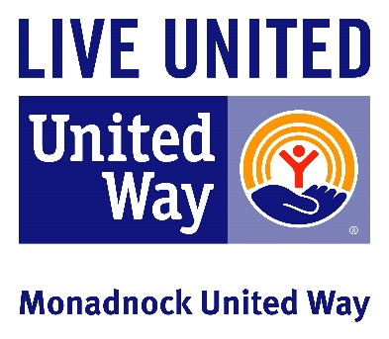

Sample phone script & elevator pitch
Initial phone call
Good (morning/afternoon)! My name is __________________ and I am volunteering for the Monadnock United Way’s annual fundraising campaign. How are you today?

I am reaching out regarding the 2022-23 annual campaign, United We All Win. As you know, this year’s campaign is more important than ever. Not only are people in this region still experiencing hardships brought on by Covid-19, MUW partner agencies still need to provide their critical programming.

I am hoping that you have a few moments to chat about MUW and your company becoming a donor? *use talking points below

Just a reminder that our campaign ends on December 31st this year to help us meet our campaign goal of $1,490,990. Can we count on your and (insert business name here) to support our community with a monetary donation?

Thank you so much!

Talking point to add in as you are comfortable:
United We ALL Win
You changed the game last year. People received food and emergency shelter. Child care centers remained open, viable and provided the best care for our community’s children. Families received essential services. Our partners, our initiatives, and the community stepped up time and again to help every person possible – because of your generosity.

Today, our community continues to strengthen. Yet we face some hard realities highlighted by the pandemic.

Too many of our neighbors are still facing hardship:
- We had the third highest rate of child abuse and neglect in the state
- Our children scored lower than the rest of the state in English and math
- One quarter of our residents were low-income. The rest of NH the rate is 1 in 5

Poverty, abuse, and low educational achievement reinforce each other; creating a downward cycle that harms a community and destroys its vibrancy. The damage seeps in over time, often taking a generation to become obvious. We can’t wait that long to act.

United we ALL can eliminate and change these realities forever.

United We ALL Win when we:
- Tackle hunger, homelessness, poverty, and child abuse
- Step up to strengthen our community every single day
- Prepare our neighbors for success in school, work, and life

With your support, we can all address today’s problems and create a strong community for tomorrow.

Give today because:

UNITED WE ALL WIN
Supporting Documents:
- 2021 Funding FAQ: https://www.muw.org/faq-2021
- Covid-19 Pages: https://www.muw.org/covid-19-relief

Campaign Goal - $1,490,990
- We must raise $1,490,990 this year so that people facing uncertainty and hardships can receive the services they need to be whole.
- Without those funds, more people will be hungry, more will lose their homes, and more children will fall behind in school and life.

How are the funds used? How much do the programs receive?
Visit https://www.muw.org/2020-investments for a complete listing of programs, funding amounts, and outcomes.

How many agencies are funded?
We fund 30 programs and initiatives across the region that provide services focusing on children, education and financial stability in every community across our region.

How many towns are served?
MUW partner agencies serve 37 towns in the region. Visit our Service Map for a complete listing.

Give Today at muw.org
Online at: muw.org
Text: MUW to 41444
Payroll deduction: See your HR department
Mail: MUW, 23 Center Street, Keene, NH 03431

