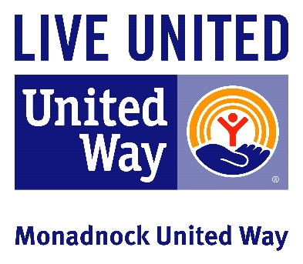

Why Good Communication is So Important
- Helps keep projects on track
- Clears up confusion
- Allows MUW to support you in your volunteer role
- Gives you access to “institutional knowledge”
- Keeps everyone energized and engaged

Types of Communication
- Phone call
- Email
- In-person meeting
- Meet for coffee
- Web call
- Stop by the office
- Facebook message
- Other?

How to Communicate
- Be clear and detailed
- Keep multiple topics separate (example: refrain from combining questions about multiple accounts in one email thread)
- Say what you mean and mean what you say
- Follow up

When in Doubt
Not sure who to contact about what? Not sure about how to proceed? Not sure if you have an issue? Need a question answered?
- Contact Kate Cote, Volunteer & Community Engagament Manager at kate@muw.org or 352-4209 ext 23

